Assignment#1

- Create a graph showing the number of hours studied and the grades earned using the below information (Take hours on X-axis and grades on Y-axis). Describe how studying hours affect grades.

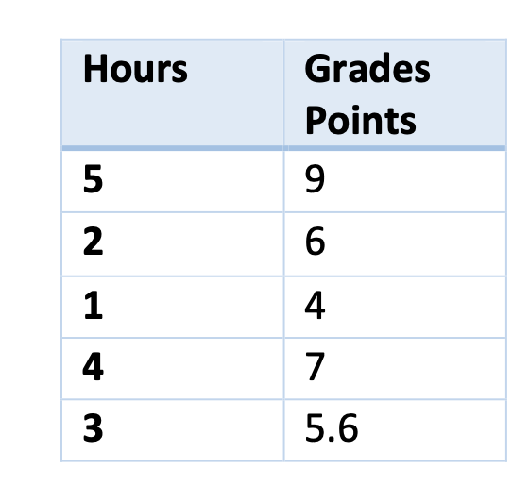
Solution:-
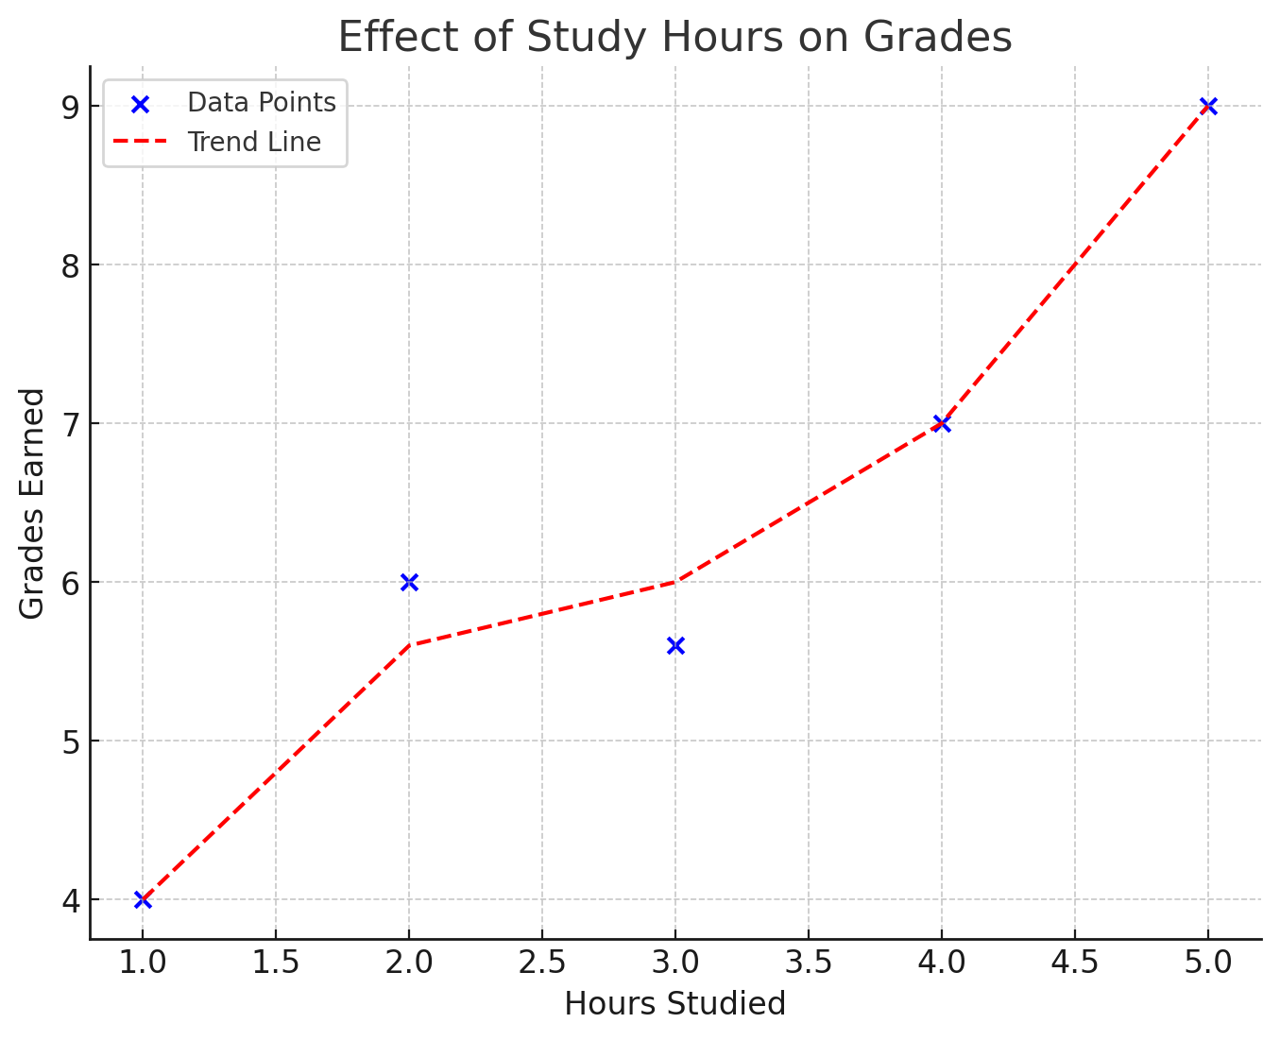
The graph visualizes the relationship between study hours and grades earned.
The trend has a positive correlation: as the number of hours studied increases, the grades tend to improve. However, the increase is not perfectly linear; for instance, studying 3 hours results in a grade of 5.6.

This suggests that while studying more generally leads to better performance, other factors (such as the quality of study time, prior knowledge, or individual learning pace) may also play a role in determining grades. The plotted points and the trend line reinforce the idea that consistent studying contributes to better academic outcome.

- Read the following Problem Statement:-
[Credit-worthiness assessment]- Predict the probability of a customer
being a potential defaulter, based on past transaction data and historical
information about customers who have defaulted/not defaulted in their
payments.

Now answer these questions:
i) What type of Machine Learning does this problem belong to? How?
ii) Referring to the Week#2 topic Formal Learning stages, list all the steps
required to implement the ML solution. (ML algorithm name not
required)
iii) If your ML solution doesn't perform as expected what do you think
might be a reason? Any ideas about how to deal with a model like that?

Solution:-
- Type of Machine Learning:
The problem belongs to Supervised Learning, because we have labeled data indicating whether a customer has defaulted or not. The goal is to learn from past transaction data to predict the probability of a future customer being a defaulter. To be more specific, this is a classification problem as the output (defaulter or not) is categorical, making it a binary classification problem.
- Referring to the Week#2 topic:
Implementing an ML solution involves the following stages:-
1. Problem Definition & Inputs/Outputs
- Samples(Instances of data)
- Features(inputs)
- Labels(output)
2. Data Collection & Dataset Preparation
- Training samples
- Validation samples
- Testing samples
3. Model Selection & Training
- Hypothesis
- Loss function
- Empirical Risk Minimization(ERM)
4. Model Evaluation & Validation
- Performance Metrics
- Probable Approximately Correct
5. Model Deployment & Monitoring
- Predictors
- Risk monitoring

- If your ML solution doesn't perform:
Issue | Possible Cause | Solution
Data Imbalance | More non-defaulters than defaulters in training data | Apply SMOTE (Synthetic Minority Over-sampling Technique) or undersampling
Overfitting | Model fits training data too well but fails on new data | Use regularization (L1/L2), cross-validation, and pruning techniques
Poor Feature Selection | Irrelevant or redundant features impacting performance | Perform feature selection techniques (PCA, Correlation Analysis)
Lack of Generalization | Model performs well on training but poorly on test data | Use PAC Learning framework to ensure generalization
Noisy Data | Missing or inconsistent values in customer records | Apply data cleaning techniques and imputation methods

- Given a Dataset below frame one predictive statement for regression and one for classification.
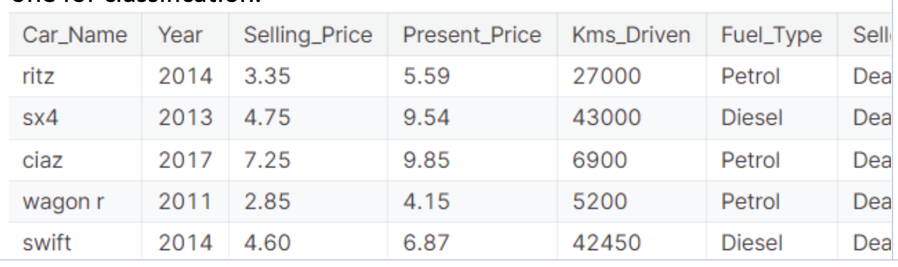
Solution:-
- Regression Predictive Statement:
The selling price of a used car can be predicted based on factors such as its present price, year of manufacture, and kilometers driven.
This is a regression problem since the target variable, Selling_Price, is continuous.)
- Classification Predictive Statement:
Based on features like the year of manufacture, kilometers driven, and fuel type, we can classify whether a car is likely to be sold by an individual or a dealer.
This is a classification problem since the target variable, Seller_Type (Dealer/Individual), is categorical.

- What are the names of the two loss functions Ls and LD that we discussed in week#2 class time? Explain in detail with examples. What is the topic connecting these two loss functions and give the equation for the same? (Your answer must be at least 50 words)
Solution:-
